**NAME – KARAN DAS**

**USER ID – 34763**

**MAIL-** [**karannnx20@gmail.com**](mailto:karannnx20@gmail.com)

**Date – 11th Aug 2025**

**Assignment Topic:**

**How to Deploy an App Using PSAppDeployToolkit (PSADT)**

**Practice Activity :-**

**PSAppDeployToolkit**;-

PSAppDeployToolkit (PSADT) is a free, open-source PowerShell framework designed to make software deployment on Windows easier, more consistent, and user-friendly.

**Key Features**

* **Silent Installs** → Handles MSI, EXE, and scripts with standard commands.
* **User Interaction** → Can show prompts, close-app warnings, or messages.
* **Logging** → Automatically creates detailed logs for troubleshooting.
* **Error Handling** → Stops or retries gracefully if something fails.
* **Detection** → Checks if an app is installed before and after deployment.

FOR Deploy Application we need to Download the File **PSAppDeployToolkit.Zip ,** After that We extract all the file .

THEN we get a file like this :-

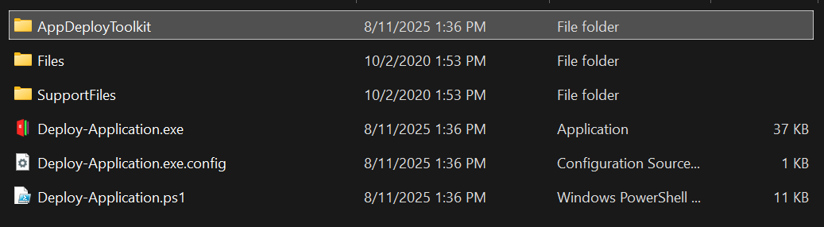

For app deploying we need to open the Deploy-Application.ps1 file in PowerShell ISE and need to add the installer like :-

Execute-MSI -Action 'Install' -Path ‘KD-Application.msi' For MSI file .

Execute-Process -Action 'Install' -Path ‘KD-Application.exe' For exe file .

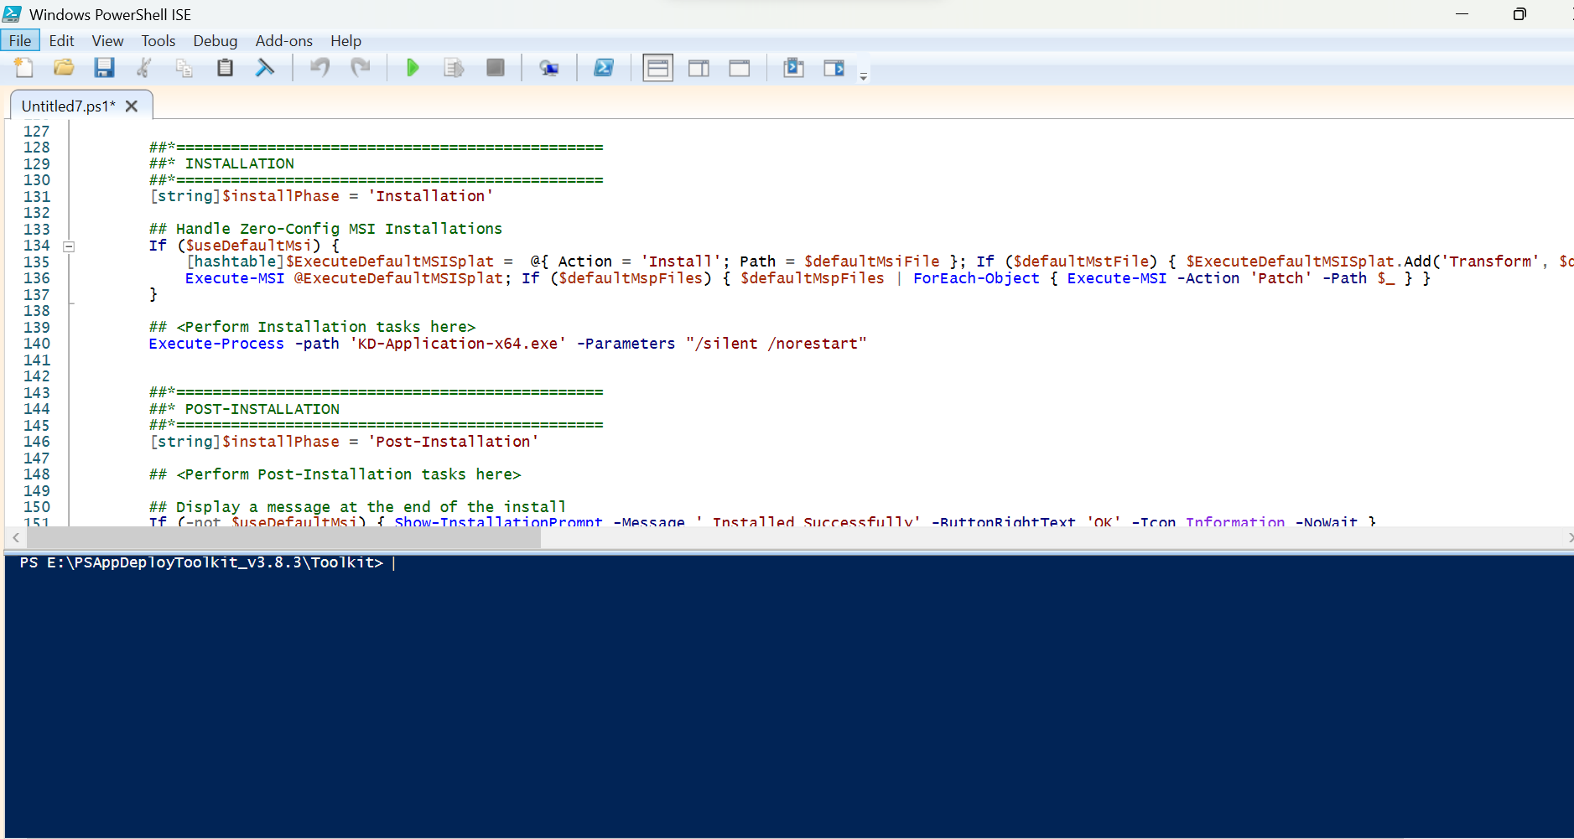

After editing all things as per our requirements to the Deploy-Application.ps1 file in PowerShell ISE.

After when We to the PSAppDeployToolkit and click Run as Administration then its doesn’t install KD-Application it show only .

I will uploaded all screenshots below what is running in my system :-

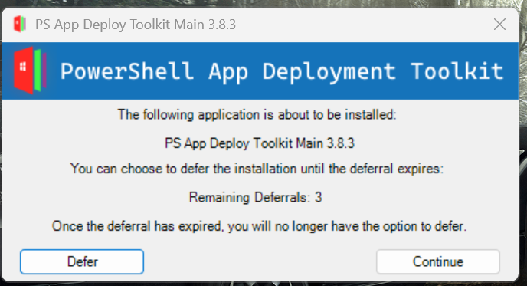

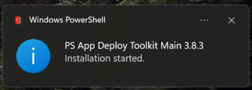

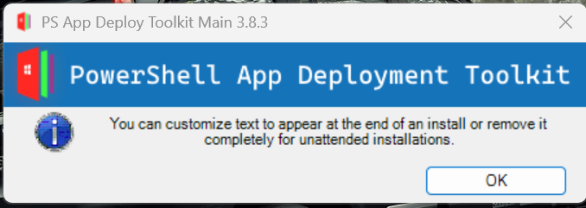

It perform only these things .